**DAILY ONLINE ACTIVITIES SUMMARY**

|  |  |  |  |  |  |  |  |  |
| --- | --- | --- | --- | --- | --- | --- | --- | --- |
| **Date:** | 21/06/2020 | | | | | **Name:** | SHREEKIRAN R BHAT | |
| **Sem & Sec** | IV sem & B section | | | | | **USN:** | 4AL18CS080 | |
| **Online Test Summary** | | | | | | | | |
| **Subject** | | **-** | | | | | | |
| **Max. Marks** | | **30** | | **Score** | | | **-** | |
| **Certification Course Summary** | | | | | | | | |
| **Course** | Blockchain Basics | | | | | | | |
| **Certificate Provider** | | | Greatlearning academy | | **Duration** | | | 2.5hours |
| **Coding Challenges** | | | | | | | | |
| **Problem Statement:** Not given | | | | | | | | |
| **Status:**  -- | | | | | | | | |
| **Uploaded the report in Github** | | | | | YES | | | |
| **If yes Repository name** | | | | | Lockdown-coding | | | |
| **Uploaded the report in slack** | | | | | YES | | | |

**Online Test Summary**: No internals conducted today.

**Online Certification Course Summary**: In today’s session I have learnt what exactly is the blockchain and how it works in the society and how blockchain solves the current problems and I came to know that it is not controlled by the user. Blockchain is the peer-to-peer network. I also came to know the difference between database and blockchain.

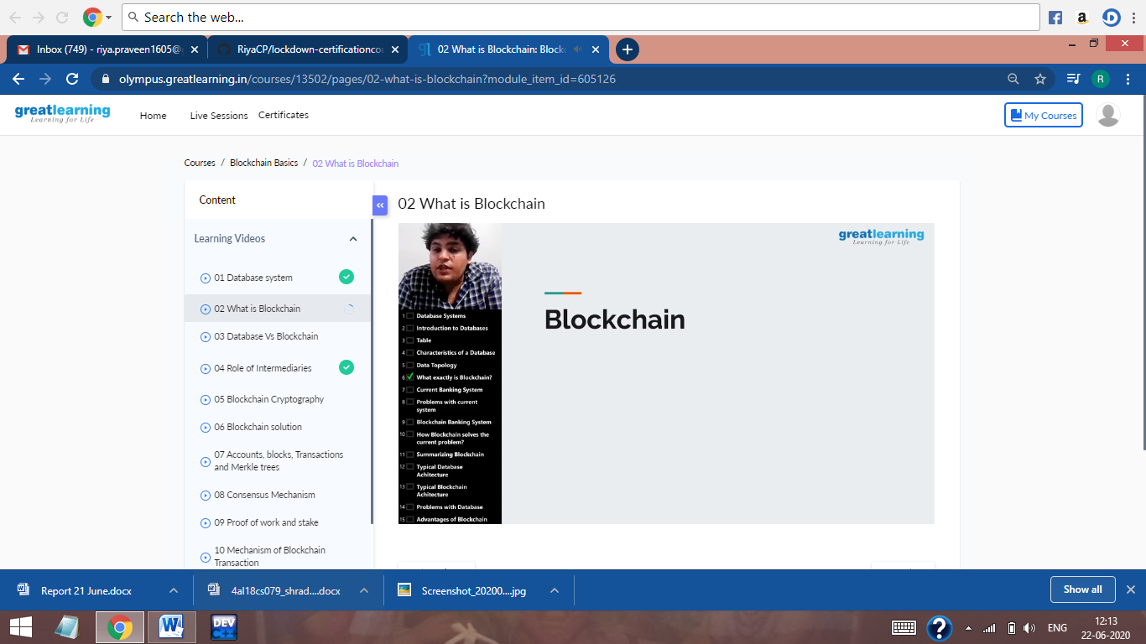

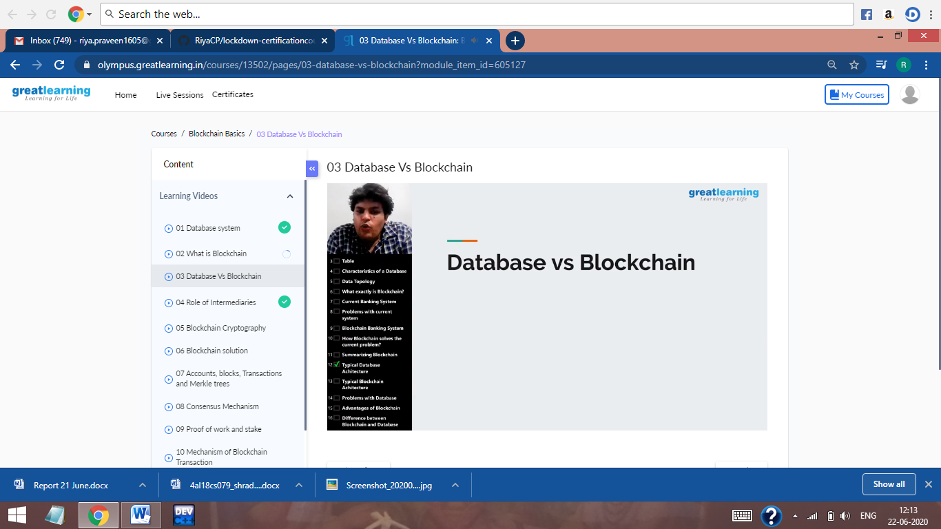

These are the snap shots of today’s sessions.

**Online Coding Summary:** No programs were given today.